Internship at the International Office,
University of Agder, Norway

The University of Agder (UiA) is looking for an intern / Erasmus+ trainee. The intern would start in early January 2022. The intern would stay with us until late August/early September 2022.
Who are we?
The University of Agder (UiA) is a young and dynamic university, recognised for its modern teaching and research facilities and innovative use of technology and communication media. UiA has approximately 13 000 students in two campuses in the very south of Norway. The Intern will be based in the main campus in the city of Kristiansand but will also work at our campus in Grimstad, and will work closely with the staff from the International Education Office and other departments (the Communication Department, the Human Resources Department…).
The main work-place will be our Global Lounge, an area designated to welcome and support International and Norwegian students, guests and staff.

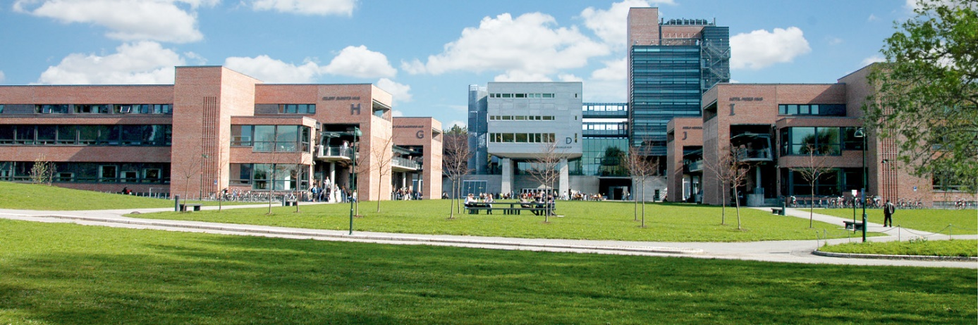

Your fields of responsibility:
- First point of contact for the International Education Office, based at the Global Lounge
- Supporting mobility team (incoming and outgoing exchange students and degree-seeking students)
- Help with marketing / promotion, social media (Facebook, Instagram) and public relations
- General administrative support (daily help with emails)
- Taking visitors on campus tours
- Coordinate language tandems
- Help establish ‘Social Erasmus’
- Help with organising activities in Global Lounge for students, staff and guests
- Support with promotion of our Summer School in European Integration

Who are we looking for?

- Student enrolled at a bachelor’s or master’s level or a recent graduate
- EU / EEA national (due to visa restrictions)
- Fluent English spoken and written (C1 level)
- Strong communication and customer service skills
- Computer skills
- Marketing and administrative experience
- Flexible and able to work independently, as well as being able to work alongside other interns
- Must be able to start at the beginning of January 2022 and stay for the required time (no short-term positions available)

Payment:
The internship is financed through the Erasmus+ program. The exact amount of your grant depends on your home country and home institution. Please check with your home office if you will be eligible for a grant before you apply.
What can we offer you?
- Varied work experience and the opportunity to bring in own ideas and create new activities
- Free single-room accommodation in student housing
- Free Norwegian Language course
- The opportunity to join international students for trips and events

To apply:

- Send your CV together with a one-page cover letter describing why you are interested in the internship and how you believe you can contribute to the team
- Supply the names and contact details of two referees (teachers, former employers, etc.) who can be contacted by us
- A Zoom interview will be required if short-listed
- Applications should be sent by e-mail to aase.galteland@uia.no by 25th November 2021
- Send e-mail to current interns at int-office@uia.no if you have questions about the positions.

