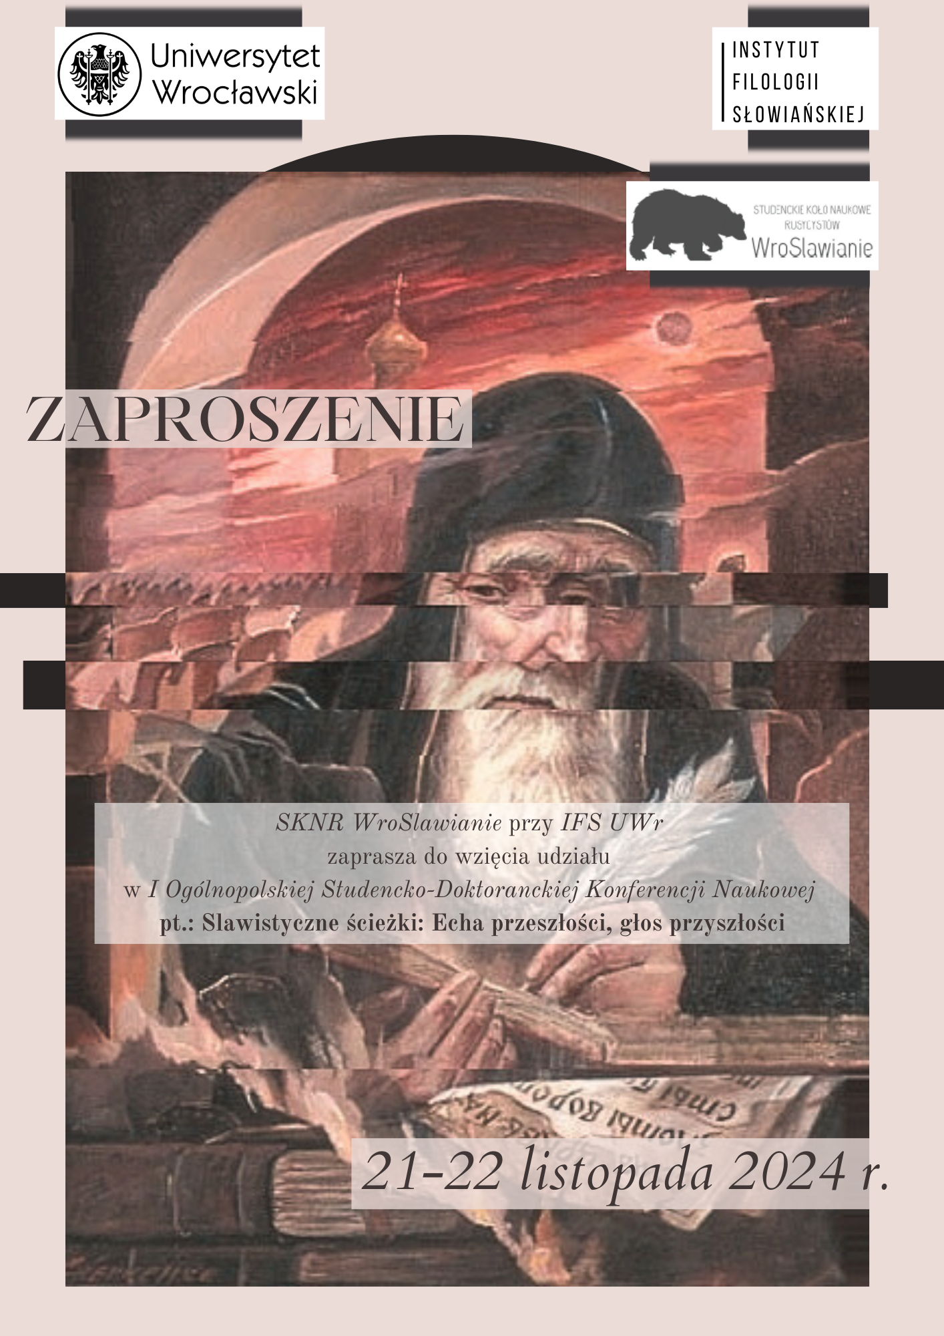

The WroSlawianie Student Scientific Circle of Russian Studies
at the Institute of Slavic Philology, University of Wrocław
invites you to participate in the
1st National Student-Doctoral Scientific Conference entitled:
Slavic Paths: Echoes of the Past, Voice of the Future.
which will be held on November 21-22, 2024.

We invite students and doctoral students to participate in the Slavic Paths: Echoes of the Past, Voice of the Future conference. The event aims to enable young researchers to present their research and academic interests in linguistics, literary studies, cultural studies, and translation. This year's edition focuses on looking at Slavic languages, literature, and culture from the perspective of new generations and showing the influence of passing events on the constant development of the surrounding world.

Proposed topics for discussion:
- Changes and development of language,
- Archaization and modernization of language
- Technological progress
- Archetype
- Change in moral and life values
- Generational conflict,
- Intergenerational trauma
- The illusion of progress and development
- Memoirs as historical sources
- Recurring trends in culture
- Return to roots - folklore then and now
- Political revolutions,
- Renaissance movements

The conference languages are Polish, Russian, and English.
The conference will be held in person and online.
In-person mode: Czasoprzestrzeń Cultural Center, ul. Tramwajowa 1-3, 51-621 Wrocław.
Online mode: on the MS-TEAMS platform.
The presentation time is 15 minutes.
After the conference, it is planned to publish the materials in a peer-reviewed multi-author monograph in electronic form. We accept abstracts by November 8, 2024. Publication specifications will be sent to participants after acceptance of the application.
Participation in the conference and publication are free of charge. Participants are responsible for their own travel and accommodation costs.
To participate in the conference, please send an electronic application and a short abstract of the paper https://forms.office.com/e/xjNRXQvi4H by October 13, 2024.
Please direct any questions to: sknr.wroslawianie@uwr.edu.pl.

Organizing Committee:
Dr Katarzyna Martyniuk
Dr Marcin M. Borowski
Julia Kożuchowska
Julia Skoczylas

